**Exploration of Water Droplet Microscope**

**2022 AI1 ZYH**

**School of Future Technology**

**South China University of Technology**

**Abstract**

This report presents a comprehensive examination of the optical properties of a water droplet used as a makeshift microscope. By exploiting the natural curvature and refractive qualities of a water droplet placed upon a glass surface, we demonstrate the droplet's capacity to function as a convex lens, magnifying objects viewed through it. The experiment was designed to elucidate the principles of magnification, optical resolution, and the diffraction limit within an accessible, low-tech environment. Employing simple yet effective methodologies, we estimated the droplet's focal length and calculated its magnifying power, drawing parallels with more sophisticated optical instruments. The findings reveal the potential of minimalistic optics for educational purposes and suggest further exploration into the use of everyday materials in demonstrating fundamental physics concepts.

**Key Words: Water droplet microscope, Optical properties, Convex lens, Magnification, Optical resolution, Diffraction limit, Low-tech optics, Focal length calculation**

1. **Experimental Objection**
2. Understand the imaging principles of a water droplet microscope.
3. Observe the phenomenon of light path magnification through a droplet.
4. Create a simple water droplet microscope and observe the magnified images of objects.
5. **Experimental Instrument**

Syringe, laser emitter, thin glass slide, water, specimen stage, fixed support stand

1. **Experimental Principles**
   1. **Optical Resolution**

Optical resolution describes the ability of an [imaging](https://en.wikipedia.org/wiki/Imaging) system to resolve detail, in the object that is being imaged. An imaging system may have many individual components, including one or more lenses, and/or recording and display components. Each of these contributes (given suitable design, and adequate alignment) to the optical resolution of the system; the environment in which the imaging is done often is a further important factor.

* + 1. **Lateral Resolution**

Resolution depends on the distance between two distinguishable radiating points. The sections below describe the theoretical estimates of resolution, but the real values may differ. The results below are based on mathematical models of [Airy discs](https://en.wikipedia.org/wiki/Airy_disc), which assumes an adequate level of contrast. In low-contrast systems, the resolution may be much lower than predicted by the theory outlined below. Real optical systems are complex, and practical difficulties often increase the distance between distinguishable point sources.

The resolution of a system is based on the minimum distance $r$  at which the points can be distinguished as individuals. Several standards are used to determine, quantitatively, whether or not the points can be distinguished. One of the methods specifies that, on the line between the center of one point and the next, the contrast between the maximum and minimum intensity be at least 26% lower than the maximum. This corresponds to the overlap of one Airy disk on the first dark ring in the other. This standard for separation is also known as the [Rayleigh criterion](https://en.wikipedia.org/wiki/Rayleigh_criterion#Explanation). In symbols, the distance is defined as follows:

Where:

1.  is the minimum distance between resolvable points, in the same units as .

2.  is the [wavelength](https://en.wikipedia.org/wiki/Wavelength) of light, emission wavelength, in the case of fluorescence.

3.  is the index of refraction of the media surrounding the radiating points.

4.  is the half angle of the pencil of light that enters the objective.

5.  is the [numerical aperture](https://en.wikipedia.org/wiki/Numerical_aperture).

This formula is suitable for confocal microscopy, but is also used in traditional microscopy. In [confocal laser-scanned microscopes](https://en.wikipedia.org/wiki/Confocal_laser_scanning_microscopy), the full-width half-maximum (FWHM) of the [point spread function](https://en.wikipedia.org/wiki/Point_spread_function) is often used to avoid the difficulty of measuring the Airy disc. This, combined with the rastered illumination pattern, results in better resolution, but it is still proportional to the Rayleigh-based formula given above.

$$r=\frac{0.4λ}{NA}$$

Also common in the microscopy literature is a formula for resolution that treats the above-mentioned concerns about contrast differently. The resolution predicted by this formula is proportional to the Rayleigh-based formula, differing by about 20%. For estimating theoretical resolution, it may be adequate.

$$r=\frac{λ}{2nsinθ}=\frac{λ}{2NA}$$

When a condenser is used to illuminate the sample, the shape of the pencil of light emanating from the condenser must also be included.

$$r=\frac{1.22λ}{{NA}_{obj}+{NA}_{cond}}$$

In a properly configured microscope, ${NA}_{obj}+{NA}_{cond}=2{NA}_{obj}$ .

The above estimates of resolution are specific to the case in which two identical very small samples that radiate incoherently in all directions. Other considerations must be taken into account if the sources radiate at different levels of intensity, are coherent, large, or radiate in non-uniform patterns.

* + 1. **Lens Resolution**

The ability of a [lens](https://en.wikipedia.org/wiki/Lens) to resolve detail is usually determined by the quality of the lens, but is ultimately [limited](https://en.wikipedia.org/wiki/Diffraction-limited_system) by [diffraction](https://en.wikipedia.org/wiki/Diffraction). Light coming from a [point source](https://en.wikipedia.org/wiki/Point_source) in the object diffracts through the lens [aperture](https://en.wikipedia.org/wiki/Aperture) such that it forms a diffraction pattern in the image, which has a central spot and surrounding bright rings, separated by dark nulls; this pattern is known as an [Airy pattern](https://en.wikipedia.org/wiki/Airy_pattern), and the central bright lobe as an [Airy disk](https://en.wikipedia.org/wiki/Airy_disk). The angular radius of the Airy disk (measured from the center to the first null) is given by:

$$θ=1.22\frac{λ}{D}$$

Where:

$θ$ is the angular resolution in radians.

$λ$ is the [wavelength](https://en.wikipedia.org/wiki/Wavelength) of light in meters.

and $D$  is the [diameter](https://en.wikipedia.org/wiki/Diameter) of the lens aperture in meters.

Two adjacent points in the object give rise to two diffraction patterns. If the angular separation of the two points is significantly less than the Airy disk angular radius, then the two points cannot be resolved in the image, but if their angular separation is much greater than this, distinct images of the two points are formed and they can therefore be resolved. [Rayleigh](https://en.wikipedia.org/wiki/John_William_Strutt,_3rd_Baron_Rayleigh) defined the somewhat arbitrary "[Rayleigh criterion](https://en.wikipedia.org/wiki/Rayleigh_criterion)" that two points whose angular separation is equal to the Airy disk radius to first null can be considered to be resolved. It can be seen that the greater the diameter of the lens or its aperture, the greater the resolution. Astronomical telescopes have increasingly large lenses so they can 'see' ever finer detail in the stars.

* 1. **Magnification**
     1. **Single lens**

The linear magnification of a [thin lens](https://en.wikipedia.org/wiki/Thin_lens) is:

$$M= \frac{f}{f-d_{o}}$$

Where $f$  is the [focal length](https://en.wikipedia.org/wiki/Focal_length) and $d_{o}$  is the distance from the lens to the object. For [real images](https://en.wikipedia.org/wiki/Real_image), $M$  is negative and the image is inverted. For [virtual images](https://en.wikipedia.org/wiki/Virtual_image), $M$  is positive and the image is upright.

With $d_{i}$  being the distance from the lens to the image, $h_{i}$  the height of the image and $h_{o}$  the height of the object, the magnification can also be written as:

$$M=-\frac{d_{i}}{d_{o}}=\frac{h_{i}}{h_{o}}$$

Note again that a negative magnification implies an inverted image.

* + 1. **Microscope**

The angular magnification of a [microscope](https://en.wikipedia.org/wiki/Microscope) is given by:

$$M_{A}=M_{o}+M_{e}$$

where $M_{o}$  is the magnification of the objective and $M_{e}$  the magnification of the eyepiece. The magnification of the objective depends on its [focal length](https://en.wikipedia.org/wiki/Focal_length) $f_{o}$  and on the distance $d$  between objective back focal plane and the [focal plane](https://en.wikipedia.org/wiki/Focal_plane) of the [eyepiece](https://en.wikipedia.org/wiki/Eyepiece) (called the tube length):

$$M_{o}= \frac{d}{ f_{o}}$$

The magnification of the eyepiece depends upon its focal length $f_{e}$  and is calculated by the same equation as that of a magnifying glass (above).

Note that both astronomical telescopes as well as simple microscopes produce an inverted image, thus the equation for the magnification of a telescope or microscope is often given with a [minus sign](https://en.wikipedia.org/wiki/Plus_and_minus_signs).

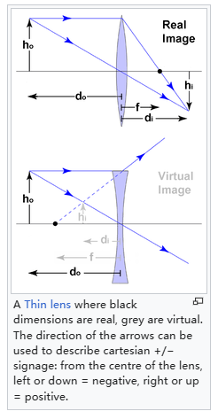

Figure 1

A Thin lens where black dimensions are real, grey are virtual. The direction of the arrows can be used to describe cartesian +/- signage: from the centre of the lens, left or down = negative, right or up= positive.

* 1. **Lens**
     1. **Construction of simple lenses**

Most lenses are spherical lenses: their two surfaces are parts of the surfaces of spheres. Each surface can be [convex](https://en.wiktionary.org/wiki/convex) (bulging outwards from the lens), [concave](https://en.wiktionary.org/wiki/concave) (depressed into the lens), or planar (flat). The line joining the centers of the spheres making up the lens surfaces is called the axis of the lens. Typically, the lens axis passes through the physical center of the lens, because of the way they are manufactured. Lenses may be cut or ground after manufacturing to give them a different shape or size. The lens axis may then not pass through the physical center of the lens.

[Toric](https://en.wikipedia.org/wiki/Toric_lens) or sphero-cylindrical lenses have surfaces with two different radii of curvature in two orthogonal planes. They have a different [focal power](https://en.wikipedia.org/wiki/Focal_power) in different meridians. This forms an [astigmatic](https://en.wikipedia.org/wiki/Astigmatism_(optical_systems)) lens. An example is eyeglass lenses that are used to correct [astigmatism](https://en.wikipedia.org/wiki/Astigmatism) in someone's eye.

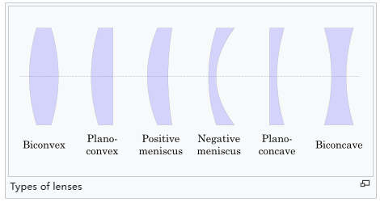

Figure 2

Lenses are classified by the curvature of the two optical surfaces. A lens is biconvex (or double convex, or just convex) if both surfaces are [convex](https://en.wiktionary.org/wiki/convex). If both surfaces have the same radius of curvature, the lens is equiconvex. A lens with two [concave](https://en.wiktionary.org/wiki/concave) surfaces is biconcave (or just concave). If one of the surfaces is flat, the lens is plano-convex or plano-concave depending on the curvature of the other surface. A lens with one convex and one concave side is convex-concave or meniscus. It is this type of lens that is most commonly used in [corrective lenses](https://en.wikipedia.org/wiki/Corrective_lenses#Lens_shape), since its shape minimizes some aberrations.

If the lens is biconvex or plano-convex, a [collimated](https://en.wikipedia.org/wiki/Collimated_light) beam of light passing through the lens converges to a spot (a focus) behind the lens. In this case, the lens is called a positive or converging lens. For a [thin lens](https://en.wikipedia.org/wiki/Thin_lens) in air, the distance from the lens to the spot is the [focal length](https://en.wikipedia.org/wiki/Focal_length) of the lens, which is commonly represented by f in diagrams and equations. An [extended hemispherical lens](https://en.wikipedia.org/wiki/Extended_hemispherical_lens) is a special type of plano-convex lens, in which the lens's curved surface is a full hemisphere and the lens is much thicker than the radius of curvature.

Another extreme case of a thick convex lens is a [ball lens](https://en.wikipedia.org/wiki/Ball_lens), whose shape is completely round. When used in novelty photography it is often called a "lensball". A ball-shaped lens has the advantage of being omnidirectional, but for most [optical glass](https://en.wikipedia.org/w/index.php?title=Optical_glass&action=edit&redlink=1) types, its focal point lies close to the ball's surface . Because of the ball's curvature extremes compared to the lens size, [optical aberration](https://en.wikipedia.org/wiki/Optical_aberration) is much worse than thin lenses, with the notable exception of [chromatic aberration](https://en.wikipedia.org/wiki/Chromatic_aberration).

* + 1. **For a spherical surface**

For a single refraction for a circular boundary, the relation between object and image is given by:

$$\frac{n_{2}}{v}+\frac{n_{1}}{u}= \frac{n_{2}-n_{1}}{R}$$

where $R$  is the radius of the spherical surface, $n_{2}$  is the refractive index of the surface, and $n_{1}$  is the refractive index of medium.

Applying this on the two spherical surfaces of a thin lens leads to the lens maker's formula.

[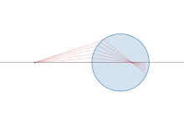](https://en.wikipedia.org/wiki/File:Refraction_at_spherical_surface.svg)

Figure 3: Simulation of refraction at spherical surface at [Desmos](https://www.desmos.com/calculator/ax4rsqdot0)

* + - 1. **Derivation**

Applying [Snell's law](https://en.wikipedia.org/wiki/Snell%27s_law) on the spherical surface, $n_{1}\sin{i}=n_{2}sinr$. Also in the diagram,

$$\tan{(i-θ)}= \frac{h}{u}$$

$$\tan{(θ-r)}= \frac{h}{v}$$

$$\sin{θ}= \frac{h}{R}$$

Using [small angle approximation](https://en.wikipedia.org/wiki/Small-angle_approximation) and eliminating $i$ , $r$ , and ,

[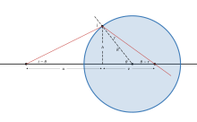](https://en.wikipedia.org/wiki/File:Refraction_in_spherical_surface.svg)

[](https://en.wikipedia.org/wiki/File:Four_spherical_refractions.png)

Figure 4: The four cases of spherical refraction

* + 1. **Lensmaker’s equation**

The focal length of a lens *in air* can be calculated from the lensmaker's equation:

$$\frac{1}{f}=\left(n-1\right)[\frac{1}{R_{1}}-\frac{1}{R_{2}}+\frac{\left(n-1\right)d}{{nR}_{1}R_{2}}]$$

Where:

1. $f$ is the focal length of the lens;
2. $n$ is the [refractive index](https://en.wikipedia.org/wiki/Refractive_index) of the lens material;
3. $R_{1}$ is the (signed, see below) [radius of curvature](https://en.wikipedia.org/wiki/Radius_of_curvature) of the lens surface closer to the light source;
4. $R_{2}$ is the radius of curvature of the lens surface farther from the light source; and
5. $d$ is the thickness of the lens (the distance along the lens axis between the two [surface vertices](https://en.wikipedia.org/wiki/Surface_vertex#Surface_vertices)).

The focal length $f$  is positive for converging lenses, and negative for diverging lenses. The [reciprocal](https://en.wikipedia.org/wiki/Multiplicative_inverse) of the focal length, $f-1$ , is the [optical power](https://en.wikipedia.org/wiki/Optical_power) of the lens. If the focal length is in meters, this gives the optical power in [diopters](https://en.wikipedia.org/wiki/Dioptre) (inverse meters).

Lenses have the same focal length when light travels from the back to the front as when light goes from the front to the back. Other properties of the lens, such as the [aberrations](https://en.wikipedia.org/wiki/Aberration_in_optical_systems) are not the same in both directions.

* + - 1. **Sign convention for radii of curvature $R_{1}$ and $R_{2}$**

The signs of the lens' radii of curvature indicate whether the corresponding surfaces are convex or concave. The [sign convention](https://en.wikipedia.org/wiki/Sign_convention) used to represent this varies, but in this article a positive R indicates a surface's center of curvature is further along in the direction of the ray travel (right, in the accompanying diagrams), while negative R means that rays reaching the surface have already passed the center of curvature. Consequently, for external lens surfaces as diagrammed above, $R_{1}> 0$   and $R_{2}> 0$  indicate convex surfaces (used to converge light in a positive lens), while $R_{1}< 0$  and $R_{S}> 0$  indicate concave surfaces. The reciprocal of the radius of curvature is called the [curvature](https://en.wikipedia.org/wiki/Curvature). A flat surface has zero curvature, and its radius of curvature is [infinite](https://en.wikipedia.org/wiki/Infinity).

* + 1. **Imaging properties**

As mentioned above, a positive or converging lens in air focuses a collimated beam travelling along the lens axis to a spot (known as the [focal point](https://en.wikipedia.org/wiki/Focus_(optics))) at a distance f from the lens. Conversely, a [point source](https://en.wikipedia.org/wiki/Point_source) of light placed at the focal point is converted into a collimated beam by the lens. These two cases are examples of [image](https://en.wikipedia.org/wiki/Image) formation in lenses. In the former case, an object at an infinite distance (as represented by a collimated beam of waves) is focused to an image at the focal point of the lens. In the latter, an object at the focal length distance from the lens is imaged at infinity. The plane perpendicular to the lens axis situated at a distance f from the lens is called the [*focal plane*](https://en.wikipedia.org/wiki/Cardinal_point_(optics)#Focal_planes).

If the distances from the object to the lens and from the lens to the image are $S_{1}$  and $S$  respectively, for a lens of negligible thickness ([thin lens](https://en.wikipedia.org/wiki/Thin_lens)), in air, the distances are related by the thin lens formula:

$$\frac{1}{f}= \frac{1}{S_{1}}+\frac{1}{S_{2}}$$

This can also be put into the "Newtonian" form:

$$f^{2}= x_{1}x_{2}$$

where $x_{1}=S_{1}-f$  and $x_{2}=S_{2}-f$ .

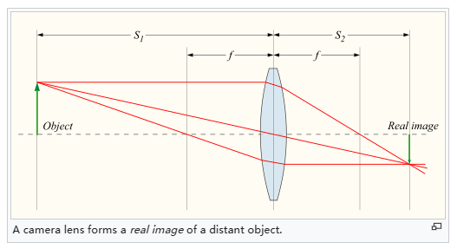

Figure 5: A camera lens forms a real image of distant object.

Therefore, if an object is placed at a distance $S_{1}>f$  from a positive lens of focal length $f$ , we will find an image distance $S_{2}$  according to this formula. If a screen is placed at a distance $S_{2}$  on the opposite side of the lens, an image is formed on it. This sort of image, which can be projected onto a screen or [image sensor](https://en.wikipedia.org/wiki/Image_sensor), is known as a [real image](https://en.wikipedia.org/wiki/Real_image). This is the principle of the [camera](https://en.wikipedia.org/wiki/Camera), and also of the [human eye](https://en.wikipedia.org/wiki/Human_eye), in which the [retina](https://en.wikipedia.org/wiki/Retina) serves as the image sensor.

The focusing adjustment of a camera adjusts $S_{2}$ , as using an image distance different from that required by this formula produces a [defocused](https://en.wikipedia.org/wiki/Defocus_aberration) (fuzzy) image for an object at a distance of $S_{1}$  from the camera. Put another way, modifying $S_{2}$  causes objects at a different $S_{1}$  to come into perfect focus.

* + 1. **Magnification**

The linear [magnification](https://en.wikipedia.org/wiki/Magnification) of an imaging system using a single lens is given by:

$$M= -\frac{S_{2}}{S_{1}}= \frac{f}{f-S_{1}}$$

where $M$  is the magnification factor defined as the ratio of the size of an image compared to the size of the object. The sign convention here dictates that if $M$  is negative, as it is for real images, the image is upside-down with respect to the object. For virtual images $M$  is positive, so the image is upright.

This magnification formula provides two easy ways to distinguish converging ($f>0$) and diverging ($f<0$) lenses: For an object very close to the lens ($0 < S_{1} < |f|$), a converging lens would form a magnified (bigger) virtual image, whereas a diverging lens would form a demagnified (smaller) image; For an object very far from the lens ($S_{1} > |f| > 0$), a converging lens would form an inverted image, whereas a diverging lens would form an upright image.

Linear magnification M is not always the most useful measure of magnifying power. For instance, when characterizing a visual telescope or binoculars that produce only a virtual image, one would be more concerned with the [angular magnification](https://en.wikipedia.org/wiki/Magnification#Angular_magnification)—which expresses how much larger a distant object appears through the telescope compared to the naked eye. In the case of a camera one would quote the [plate scale](https://en.wikipedia.org/wiki/Plate_scale), which compares the apparent (angular) size of a distant object to the size of the real image produced at the focus. The plate scale is the reciprocal of the focal length of the camera lens; lenses are categorized as [long-focus lenses](https://en.wikipedia.org/wiki/Long-focus_lens) or [wide-angle lenses](https://en.wikipedia.org/wiki/Wide-angle_lens) according to their focal lengths.

Using an inappropriate measurement of magnification can be formally correct but yield a meaningless number. For instance, using a magnifying glass of 5 cm focal length, held 20 cm from the eye and 5 cm from the object, produces a virtual image at infinity of infinite linear size: $M = ∞$ . But the angular magnification is 5, meaning that the object appears 5 times larger to the eye than without the lens. When taking a picture of the [moon](https://en.wikipedia.org/wiki/Moon) using a camera with a 50 mm lens, one is not concerned with the linear magnification $M≈-50 mm / 380000 km=-1.3×{10}^{-10}$ . Rather, the plate scale of the camera is about 1°/mm, from which one can conclude that the 0.5 mm image on the film corresponds to an angular size of the moon seen from earth of about 0.5°.

In the extreme case where an object is an infinite distance away, $S_{1} = ∞$ , $S_{2} = f$ and $M = -f/∞ = 0$ , indicating that the object would be imaged to a single point in the focal plane. In fact, the diameter of the projected spot is not actually zero, since [diffraction](https://en.wikipedia.org/wiki/Diffraction) places a lower limit on the size of the [point spread function](https://en.wikipedia.org/wiki/Point_spread_function). This is called the [diffraction limit](https://en.wikipedia.org/wiki/Diffraction_limit).

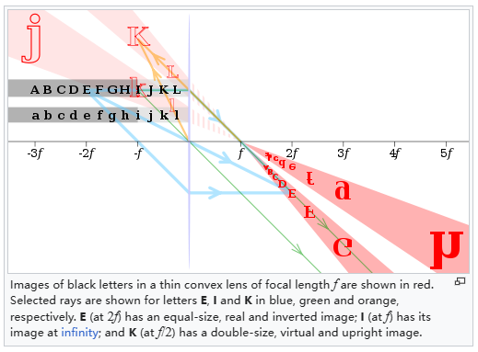

Figure 6

* 1. **Meniscus(liquid)**

A concave meniscus occurs when the attraction between the particles of the liquid and the container ([adhesion](https://en.wikipedia.org/wiki/Adhesion)) is more than half the attraction of the particles of the liquid to each other ([cohesion](https://en.wikipedia.org/wiki/Cohesion_(chemistry))), causing the liquid to climb the walls of the container. This occurs between water and glass. Water-based fluids like sap, honey, and milk also have a concave meniscus in glass or other [wettable](https://en.wikipedia.org/wiki/Wetting) containers.

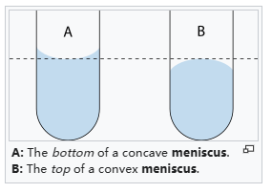

Figure 7

Conversely, a convex meniscus occurs when the adhesion energy is less than half the cohesion energy. Convex menisci occur, for example, between [mercury](https://en.wikipedia.org/wiki/Mercury_(element)) and [glass](https://en.wikipedia.org/wiki/Glass) in barometers and thermometers.

* 1. **The Principle of Water-Drop Projector**

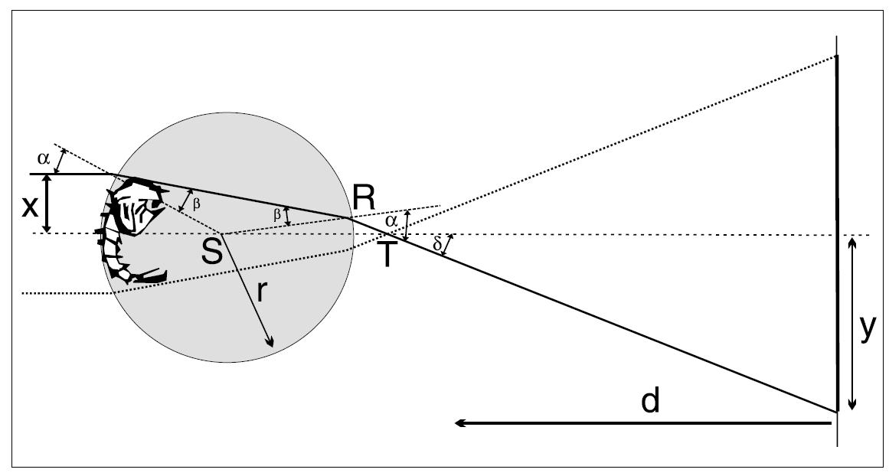

Figure 8: Optics of the water-drop projector

The drop at the end of the syringe, though not a perfect sphere, can be treated as a small spherical lens. The light beam that falls on the drop refracts both times as it passes through the water-air interface. Let’s follow the path of the ray that enters the water drop just above an object that floats in the water drop at a small distance x from the geometrical axis (Fig. 8). The ray will refract twice and reach the screen at the distance y below the geometrical axis. The distance y is determined by the distance from the drop to the screen d and the angle 3, which can be calculated using simple geometry:

$$δ=α-∠RST$$

$$∠RST=2β-α$$

$$δ=2(α-β)$$

Using Snell's law,

$$\frac{\sin{α}}{\sin{β}}= \frac{n}{n_{0}}$$

where for the water and air $n=1.33$ and $n_{0}=1.0$, respectively), and with sin $α= x/r$, the angle $δ$ is given by the equation:

$$δ=2(arcsin\frac{x}{r}-arcsin\frac{x}{nr})$$

For the rays close to the geometrical axes (paraxial region), all the angles in the calculation above are very small; therefore, the expression for $δ$ can be simplified using the approximation $arcsin(z) ≈ z$:

$$δ=2\frac{x}{r}(1-\frac{1}{n})$$

The projected image on the screen is a magn1fied shadow of the object (animal) with magnification equal to:

$$M=\frac{y}{x}=\frac{dtanδ}{x}≈2\frac{d}{r}\left(1-\frac{1}{n}\right)$$

Where the approximation ($tanδ≈δ$) is valid inthe paraxial region. For the water drop 2 mm indiameter, the shadow image on the screen 2 mfrom the setup is about 1000 times larger thanthe object. Note that in derivation we assumedthe object floats on the laser side of the drop. It can be seen that the same shadow height can be produced by a smaller object placed on the screen side of the drop (or anywhere in between). Clearly the magnification is largest for the objects that are floating in the screen side of the drop. In this case:

$$M_{max}=\frac{d}{2r}∙\frac{n}{2-n}$$

in the paraxial region. For the parameters as given above, the magnification factor is 1985.

The results show that in the paraxial region, the magnification depends on the position of the object along the geometrical axis but not on the object's distance from the axis. However, if the size of the object is comparable to the size of the drop or the object lies away from the geometrical axis, the angles $α$, $β$, and $δ$ are not small any more. In this case, the magnification is expressed using the exact expression for the angle $δ$:

$$M=\frac{d}{r}\left[\frac{1}{u}\tan\left(2\left(arcsinu-arcsin\frac{u}{n}\right)\right)\right]$$

Where the distance of the incident ray from the geometrical axis is measured in the units of water drop radius ($u = x/r$) and can have any value between 0 and 1. The magnification as the function of parameter u is shown in Fig. 4 with the set of parameters given earlier. We can deduce from the graph that the magnification is reasonably constant within the region about half radius from the geometrical axis. This gives us a hint about the size of the drop for the given laser-beam diameter if we want to produce non-distorted shadow images.

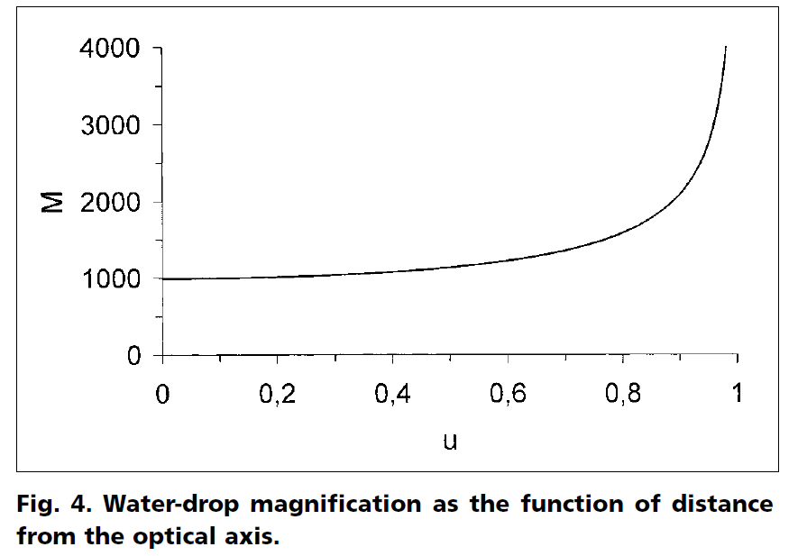

Figure 9: Water-drop magnification as the function of distancefrom the optical axis.

The preceding derivation is based on the assumption that the water drop is a perfect sphere. Though the bottom part of the drop is spherical to a good approximation, the upper part (where the drop issues from the nozzle) is seriously distorted. The light passing through this irregularly curved surface causes a variety of patterns that disturb our observation but are interesting subjects to explore themselves. However, there are other ways to make a water drop lens that is closer to a sphere than the one we suggest. For example, wrap a copper wire (thickness of 0.2mm or so) to make a small ring, then touch the ring with the water drop hanging from the syringe. The surface tension will make the drop jump onto the ring, where it will stay and for man almost perfect sphere. Or simply touch the drop from the syringe with a microscope glass plate and you'll get a nice plan-concave lens. These alternatives can be used to observe the small animals in the pond water, and the observed shadow images may be even better than those obtained with the hanging water drop method. But the advantage of this method is the simple construction and the fact that you can have many animals inside the syringe. The little animals attracted by the light swim down into the drop by themselves. With the other methods, getting the animals into the drop maybe difficult, and the observation time is limited by the evaporation of the drop.

1. **Experimental Procedures**
   1. **Observation of Light Path Magnification Through a Water Droplet**

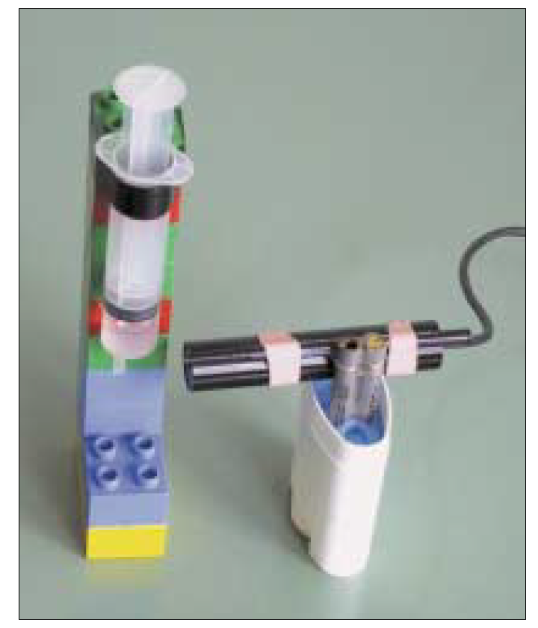

Figure 10

As shown in the figure, arrange the experimental equipment as depicted above.

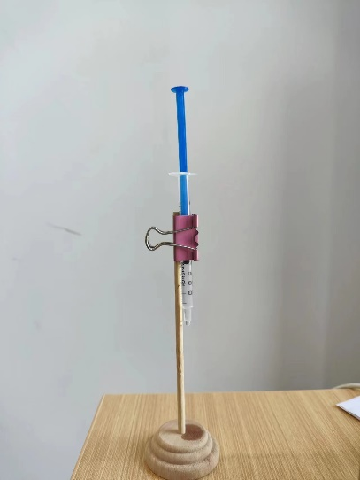

Figure 11

* + 1. **Objective**

To observe and quantify the magnification effect of a water droplet on a laser beam by measuring the size of the light circle on a wall at varying distances from the droplet.

* + 1. **Materials**

1. Syringe (to create a water droplet)
2. Laser pointer (for a coherent light source)
3. Ruler or measuring tape (for distance measurements)
4. Protractor or angle measuring tool (to measure the angle of refraction)
5. Stand or clamp (to hold the syringe steady)
6. Plain wall or screen (as a backdrop for observing the light circle)
7. Paper and pen (for recording measurements)
   * 1. **Procedure**

**Setup Preparation:**

Attach the syringe to the stand, ensuring it's positioned horizontally and securely.

Select a plain wall or screen as a backdrop for the experiment, preferably in a dimly lit room to clearly observe the laser light.

**Creating the Water Droplet:**

Draw a consistent volume of water into the syringe.

Carefully expel a single water droplet to hang at the syringe's tip, making sure the droplet size is consistent for each trial.

**Initial Measurement:**

Place the laser pointer so that its beam will pass directly through the center of the droplet.

Measure and record the initial distance from the center of the water droplet to the wall ($D$).

**Conducting the Experiment:**

Turn on the laser pointer to project the beam through the water droplet onto the wall.

Observe the magnified light circle formed on the wall due to the refraction through the droplet.

Measure the diameter of the light circle and calculate its radius ($r$).

Record these measurements.

**Varying the Distance:**

Carefully adjust the distance ($D$) between the droplet and the wall, increasing in measured increments.

Repeat the measurement of the light circle's radius ($r$) at each new distance.

Continue collecting data for a range of distances.

Calculating Refraction Angle:

Using Snell's Law and trigonometry, calculate the expected angle of refraction ($θ_{2}$ ​) and the theoretical radius of the light circle for each distance.

**Data Analysis:**

Plot the measured values of $r$ against $D$ and compare with the theoretical values calculated.

To calculate the refraction angle of a laser beam passing through a water droplet, you'll need to use Snell's Law. Snell's Law relates the angle of incidence and the angle of refraction for a ray of light passing through the interface between two media with different refractive indices.

The formula for Snell's Law is:

$$n_{1}\sin{θ_{1}}=n_{2}\sin{θ_{2}}$$

Where:

- is the refractive index of the first medium (air, in this case, which is approximately 1).

- is the angle of incidence, which is the angle between the incoming laser beam and the normal (perpendicular) to the surface at the point of incidence.

- is the refractive index of the second medium (water, which has a refractive index of about 1.33).

- is the angle of refraction, which is the angle you're trying to find.

Since the laser beam is incident straight-on, $θ_{1}$ is 0 degrees (the beam is perpendicular to the surface of the droplet). Therefore, the formula simplifies to:

$$\sin{θ_{2}}= \frac{n_{1}}{n_{2}}$$

Given that $n_{1}$ (for air) and $n_{2}≈1.33$ (for water), you can solve for $θ_{2}$. This will give you the angle at which the laser beam exits the water droplet.

$$θ_{2}=\sin^{-1}{\frac{n_{1}}{n_{2}}}=48.75°$$

$$\tan{θ_{2}}=\tan{48.75}°=1.1404$$

Keep in mind that this calculation assumes ideal conditions, like a perfectly spherical water droplet and a laser beam hitting exactly at the center. Real-world conditions might introduce some variations.

To connect the refraction angle calculated using Snell's Law with the two physical quantities you measured in your experiment (the distance from the water droplet to the wall $D$ and the radius of the light circle on the wall $r$), you can use basic trigonometry. The idea is to relate the angle at which light exits the droplet to the size of the light circle projected on the wall.

From Snell's Law, you've calculated the refraction angle $θ_{2}$. This is the angle at which the laser light exits the water droplet. Once the light exits the droplet, it spreads out linearly. The geometry of this situation forms a right triangle, with $D$ as the adjacent side (distance from droplet to wall), $r$ as the opposite side (radius of the light circle), and $θ_{2}$ as the angle at the droplet.

The tangent of $θ_{2}$ is defined as the ratio of the opposite side to the adjacent side in a right-angled triangle. Therefore, you can write:

$$\tan{θ_{2}}=\frac{r}{D}$$

Rearranging this formula gives:

$$r=D∙\tan{θ_{2}}$$

This equation connects the refraction angle to the observed magnification effect. By measuring $D$ and $r$, and knowing $θ_{2}$ (calculated from Snell's Law), you can verify this relationship. If you vary $D$ in your experiment and measure $r$ each time, you should be able to see how the size of the light circle changes in accordance with this trigonometric relationship, reflecting the behavior of light as it passes through and exits the water droplet.

Analyze how the light circle's size changes with the distance and verify the behavior against the theoretical model.

* + 1. **Expected Outcome**

The radius of the light circle ($r$) should increase as the distance ($D$) from the droplet to the wall increases, in accordance with the trigonometric relationship $r=D∙\tan{θ_{2}}$.

The experiment will demonstrate the magnifying properties of a water droplet and the principles of light refraction.

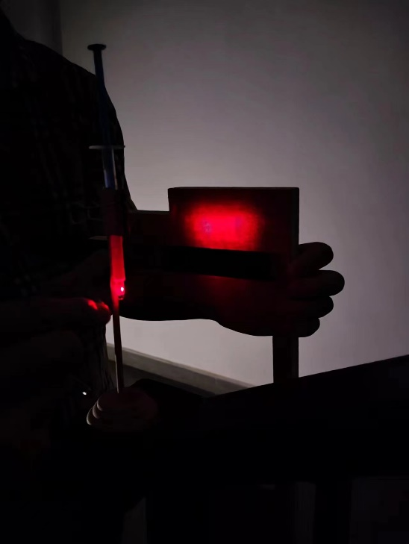

Figure 12: The place where we conduct the experiment needs to be dark.

* 1. **Creation and Observation of Magnified Images with a Water Droplet Microscope**

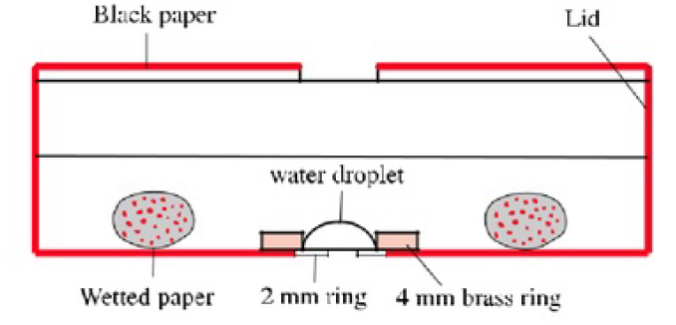

Figure 13

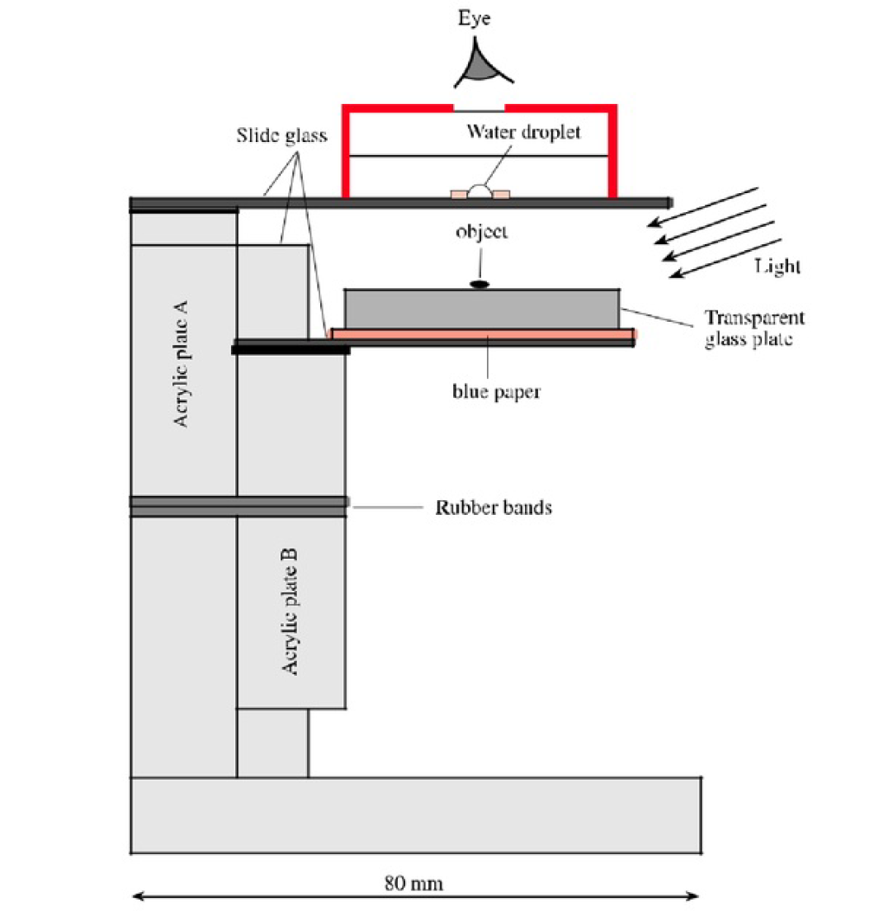

Figure 14

As shown in the figure, arrange the experimental equipment as depicted above.

* + 1. **Objective**

To construct a simple water droplet microscope and observe the changes in the size of the magnified image of a small object as the distance between two glass slides is varied.

* + 1. **Materials**

1. Two transparent thin glass slides
2. Water
3. Small object for observation (e.g., a section of a leaf or a printed text)
4. Adjustable stand to change and maintain the distance between the slides
   * 1. **Procedure**
5. Place a small object on the lower glass slide.
6. Use the syringe to place a water droplet on the underside of the upper glass slide.
7. Carefully align the upper glass slide above the lower one so that the water droplet is directly over the object.
8. Secure the slides in a stand that allows you to adjust the vertical distance between them.
9. Observe the object through the water droplet from a vertical position.
10. Gradually adjust the distance between the two slides and note any changes in the size of the observed image.

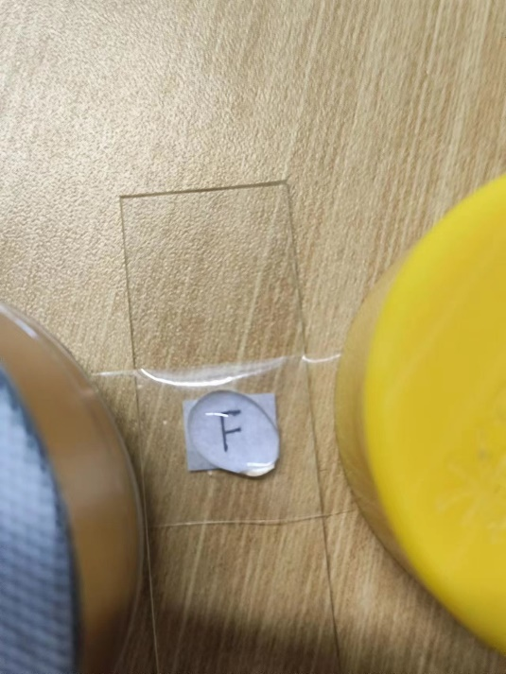

Figure 15

* 1. **Measurement of Focal Length of a Water Droplet**

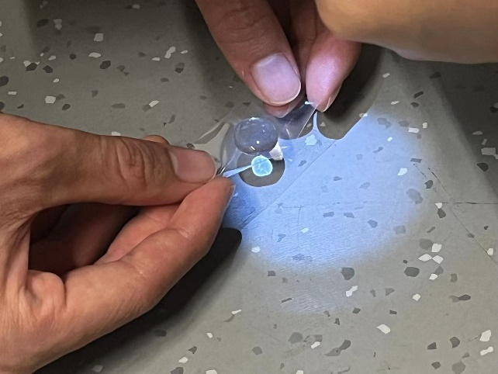

Figure 16

* + 1. **Objective**

To measure the focal length of a water droplet by observing the focusing effect of white light passing through it and analyzing the light pattern formed on a surface below the droplet.

* + 1. **Materials**

1. White light source with a defined radius (preferably a collimated beam)
2. Syringe (to create a water droplet)
3. Transparent, flat surface (like a glass slide)
4. Ruler or measuring tape (for distance measurements)
5. Paper and pen (for recording measurements)
6. Stand or clamp (to hold the syringe and light source)
   * 1. **Procedure**

**Setup Preparation:**

Set up the light source above the flat surface so that it shines vertically downwards.

Attach the syringe to a stand, positioning it so a water droplet can form below the light source and above the surface.

**Forming the Water Droplet:**

Fill the syringe with water.

Carefully expel a single droplet at the tip of the syringe, ensuring its stability.

**Illuminating the Droplet:**

Turn on the light source, directing the beam through the center of the droplet.

Ensure the light is perpendicular to the surface.

**Observing Light Patterns:**

Observe the light pattern formed on the surface.

Depending on the distance, you might see a focused point, an unfocused light circle, or an inverted light circle.

**Measurement and Calculation:**

Record at least two sets of measurements for $r$ and $D$. More data points will provide a more accurate analysis.

For each set of measurements, calculate the focal slope ($s$) of the light rays, which is the ratio of $r$ to $D$. The slope can be determined by $s=\frac{D}{R-r}$.

Average the slopes from your different measurements to get a more accurate representation.

Finally calculate the focal length of the water drop $f$:

$$f=R×s$$

1. **Data Processing**
   1. **Observation of Light Path Magnification Through a Water Droplet**

|  |  |  |  |  |
| --- | --- | --- | --- | --- |
| Measurement | $$D$$ | $$d$$ | $$r$$ | $$\frac{r}{D}$$ |
| 1 | 5cm | 11.7cm | 5.85cm | 1.17 |
| 2 | 10cm | 22.8cm | 11.4cm | 1.14 |
| 3 | 15cm | 35.4cm | 17.7cm | 1.18 |
| 4 | 20cm | 46.8cm | 23.4cm | 1.17 |

Table 1

Let $α=\frac{r}{D}$, by calculating the average number of those four measurements, we can obtain that:

$$\overline{α}=\frac{α_{1}+α_{2}+α_{3}+α_{4}}{4}=\frac{1.17+1.14+1.18+1.17}{4}=1.165$$

Because that:

$$\tan{θ_{2}}=\tan{48.75}°=1.1404$$

We can conclude that $\overline{α}=\frac{r}{D}≈\tan{θ_{2}}=1.1404$.

Compare the average experimental ratio $\overline{α}$ (which is $\frac{r}{D}$) to the theoretical value of $\tan{θ_{2}}$. The error rate can be determined using the formula for percentage error, which is:

$$Error State= \left|\frac{Experimental Value-Theoretical Value}{Theoretical Value}\right|×100\%$$

By using the formula above, we can obtain the error state:

This indicates a relatively small deviation of the experimental results from the theoretical predictions, suggesting good accuracy in the experimental setup and measurements.

* 1. **Measurement of Focal Length of a Water Droplet**

The radius of the known water droplet $R=0.8cm$.

|  |  |  |  |  |
| --- | --- | --- | --- | --- |
| Measurement | $$r$$ | $$D$$ | $$s$$ | $$f$$ |
| 1 | 0.64cm | 0.5cm | 3.125 | 2.50cm |
| 2 | 0.45cm | 1.0cm | 2.937 | 2.35cm |
| 3 | 0.31cm | 1.5cm | 3.075 | 2.46cm |

Table 2

Calculate the average focal length as $\overline{f}$:

$$\overline{f}=\frac{f_{1}+f_{2}+f_{3}}{3}=\frac{2.5+2.35+2.46}{3}cm=2.437cm$$

Then adjust the height of the water drop so that the light gathered on the plane is a light point, and the distance from the water drop to the plane is the focal length $f$.

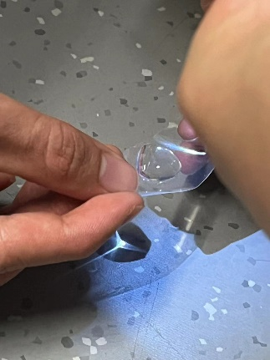

Figure 17: The focal point of the water droplet is exactly on the plane.

At this point, the distance between the water droplet and the plane is measured as $d=2.40cm$.

The error rate can be determined using the formula for percentage error, which is:

$$Error State= \left|\frac{Experimental Value-Theoretical Value}{Theoretical Value}\right|×100\%$$

By using the formula above, we can obtain the error state:

This indicates a relatively small deviation of the experimental results from the theoretical predictions, suggesting good accuracy in the experimental setup and measurements.

1. **Conclusions and Analysis**

**Observation of Light Path Magnification Through a Water Droplet:**

**1. Conclusion:**

The experiment successfully demonstrated the magnifying properties of a water droplet acting as a convex lens. The increase in the radius of the light circle with the distance from the droplet to the wall was consistent with the theoretical expectations based on the principles of light refraction and Snell's Law.

**2. Analysis:**

The calculated average ratio $\overline{α}=\frac{r}{D}$ showed a close approximation to the theoretical value of $\tan{θ_{2}}$, indicating the experimental setup's accuracy. An error rate of 2.16% suggests a high degree of precision in the measurements and validates the experimental approach.

The slight deviation might be attributed to factors such as the non-perfect sphericity of the water droplet, variations in droplet size, or minor alignment issues of the laser beam.

**Measurement of Focal Length of a Water Droplet:**

**1. Conclusion:**

The measurements of the focal length of the water droplet using the slope method were consistent and yielded a small average error rate of 1.54%. This confirms the water droplet's capability to focus light effectively and acts as a simple lens.

**2. Analysis:**

The average focal length calculated from the slope measurements ($\overline{f}=2.437cm$) closely matched the focal length observed directly ($d=2.40cm$), reinforcing the reliability of the slope method in such experimental setups.

The minor error could result from factors like the uneven surface of the water droplet, the precision in measuring the diameter of the light circle, or the exact alignment of the droplet with the light source.

**Overall Assessment:**

These experiments effectively demonstrate the potential of using a simple water droplet as a makeshift microscope, highlighting the basic principles of optics through an accessible and innovative approach.

The findings significantly contribute to our understanding of how everyday materials like water can be utilized in practical optics, particularly in magnification and focusing, akin to more complex and sophisticated optical instruments.

The precision and accuracy achieved in the experiments underline the importance of careful measurement and setup in optical experiments, even when using rudimentary tools like syringes and water droplets.

The water droplet microscope serves as a powerful educational tool, offering a tangible and intuitive way to explore and understand key concepts in optics, such as light refraction, focal length, and the magnifying properties of lenses.

Future explorations could include investigating the effects of varying droplet sizes, shapes, and consistencies, or comparing the optical properties of different liquids. Such experiments could further enhance our understanding of optics and its applications in everyday life, potentially inspiring new, low-cost optical tools and teaching aids.

The simplicity and effectiveness of the water droplet microscope make it an excellent example of practical physics and resourcefulness, demonstrating that significant scientific exploration can be conducted with minimal resources.